EEEE3001 / EEEE4008

Final Year Individual Project Proposal

Diode Clamped Converter for Vehicle AC machine Drive

AUTHOR: Mr. Pengyuan Shu

ID NUMBER: 20321149

SUPERVISOR: Dr. Alan Watson

MODERATOR: Dr. Gaurang Vakil

DATE: 25 October 2023

**Project files and overall progress are available at:**

<https://github.com/ssyps2/PMSM_Motor_FOC>

1. **Overview**
   1. **Introduction**

In the contemporary landscape characterized by a growing emphasis on clean and sustainable energy sources, the integration of battery-connected Permanent Magnet Synchronous Machine (PMSM) drives assumes a pivotal role across diverse applications, most notably in the domain of electric vehicles. These systems leverage the distinctive architecture of multilevel converters, enabling the generation of multi-level AC voltage waveforms sans the requirement of transformers. Diode Clamped Converter (DCC) is one of the types of multilevel topologies, which is commonly used as drives for high frequency motors as a result of their superior waveform quality [1]. This intrinsic characteristic empowers it to produce high-frequency AC voltages for the PMSM, characterized by notably diminished harmonic distortion. Consequently, the need for extensive filtering and the associated pulsations stemming from these harmonics is substantially reduced.

A fundamental aspect of the PMSM motor is its rotor, which comprises permanent magnets, thus obviating the need for magnetizing current. In this configuration, the motor's torque is solely generated by the stator current. Owing to this inherent efficiency, PMSM motors find widespread application in fields such as robotics and aerospace, where minimizing losses in the rotor is of paramount importance. The control of PMSM motors typically hinges on the Field Oriented Control (FOC) methodology, which can be used to control the AC quantities (voltage, current) [2, 3]. Against this backdrop, the primary focus of this project is to explore the integration of the Diode Clamped Converter into the PMSM drive [4]. For safety reasons, only low-power scenarios (2kW) will be considered. The potential ramifications of this endeavour extend to a wide array of domains, including electric vehicles, renewable energy systems, robotics, and beyond. The successful execution of this project bears the promise of delivering more efficient energy solutions, and in so doing, opens the door to fresh commercial opportunities and contributes to broader economic growth.

* 1. **Aim**

The aim of this project is to simulate a 3-Phase Diode Clamped Inverter as a battery connected Permanent Magnet Synchronous Machine (PMSM) drive, and design a PCB to implement a low power version of this type of converter. The control algorithm will be tested in PLECS and eventually implemented in the F28379D micro-controller. Torque, speed, and mechanical position closed loop control of the PMSM motor will be included.

* 1. **Objectives**

1. **Simulation**

The main topology of the circuit for simulation in the PLECS is shown in **Figure 1**.

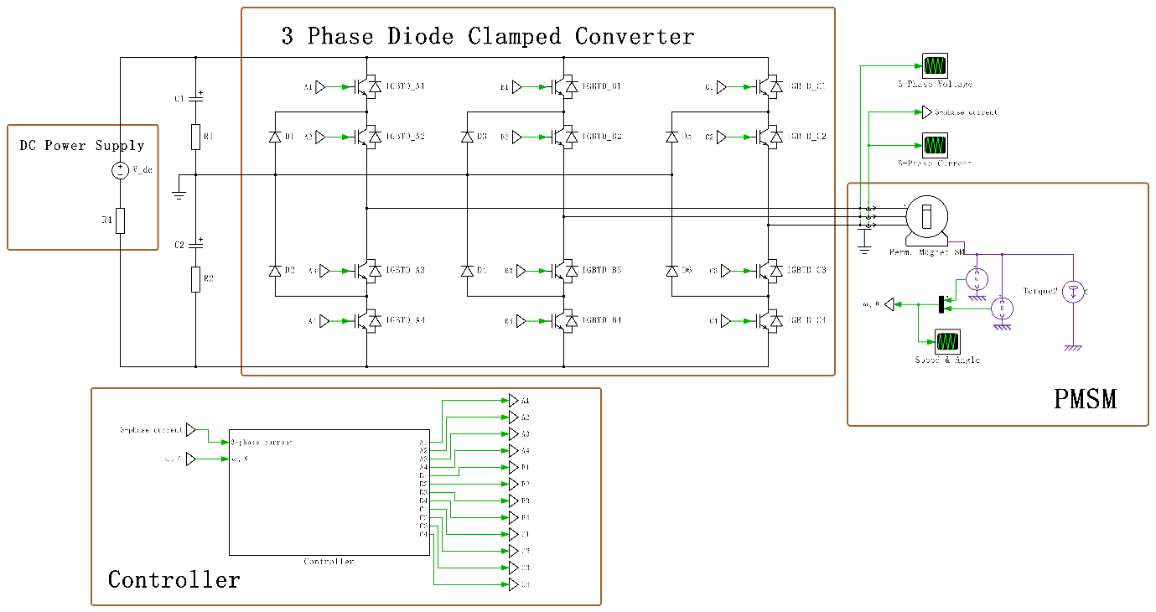

**Figure 1.** Main Topology for Simulation

1. **PCB Design**

The circuit designed in the simulation will be implemented in a 2-layer Printed Circuit Board (PCB), which is a medium used to integrate all the electrical components. Surface Mount Technology (SMT) will be applied for more compact layout, higher design flexibility, and reducing the noise interference. The microcontroller is selected to be TI’s **LAUNCHXL-F28379D**, which is a 32-bit MCU with frequency up to 200MHz and sufficient communication interface (like UART, CAN, I2C) and high-speed PWM channels. Also, current sensor will be used to detect the 3-phase current and sampled by ADC to complete the torque control loop.

1. **Specification**
   1. **Software**

The controller takes the 3-phase current and PMSM motor’s angle and speed as input, and output the PWM for each IGBT in the diode clamped converter. The controller contains three closed loops in series: torque loop, speed loop and mechanical position loop. The most fundamental loop is torque loop, which also can be referred to as current loop, as the torque of the PMSM motor is proportional to its stator current. This is where the FOC algorithm can be applied, combined with the PI controller to control the three-phase current in a closed loop to generate target torque based on the mechanical position of the rotor. Building upon the foundation of torque closed loop, the speed and mechanical angle loop can be implemented by using the serial PI controller.

* 1. **Hardware**

The specification for 3 phase PMSM motor would be like:

|  |  |
| --- | --- |
| Power Rating | 2kW |
| Frequency Rating | 50Hz/60Hz |
| Supply Voltage | 150-200V |

Based on the requirement above, several key components are selected and listed in **Table 1**.

**Table 1.** List of Key Components

|  |  |  |  |  |
| --- | --- | --- | --- | --- |
| **Items** | **Models** | **Manufacturer** | **Price (each)** | **Availability** |
| MCU | LAUNCHXL-F28379D | TI | $39 | Available Now |
| IGBT | RGCL60TK60 | [ROHM Semiconductor](https://www.mouser.co.uk/manufacturer/rohm-semiconductor/) | £4.06 | In stock |
| Isolated gate driver | HCPL-3120-500E | DigiKey | £2.66 | In stock |
| Current sensor | ACS723LLCTR-40AB-T | DigiKey | £4.79 | In stock |
| Hight voltage capacitor | MAL215299606E3 | Vishay Semiconductors | £3.16 | In stock |

Those “long lead time” components should be ordered as soon as possible early in the project.

* 1. **Criteria for Success**

1. PCB has no significant heating and vibration noise during operation.
2. Clear and correct 3 phase waveforms of both simulation and practical testing results.
3. Torque / speed / mechanical position of PMSM motor can be fully controlled by Qt-based HMI.
4. **Methodology**

|  |  |  |
| --- | --- | --- |
| **No.** | **Goals and Processes** | **Challenges** |
| 1 | Read related resources to get familiar with the diode clamped converters and PMSM drives. | NA |
| 2 | [Hardware]  Select components according to the requirements (manufacturers can be Mouser, RS, Farnell…). The process is basically applying filter to exclude most irrelevant options, and compare those roughly fitted, then choose and order the best fit one (cheap / low loss / high tolerant…). | Some components might be unavailable / too expensive / take too long to ship |
| 3 | [Hardware]  Draw schematics based on selected components in KiCad, assign footprints to each component, and draw footprints that cannot found in the library. | Techniques for voltage balance between capacitors should be considered to prevent distortion. |
| 4 | [Hardware]  Plan PCB layout in KiCad, draw traces (ensure they are wide enough to handle large current) to connect components. Send project files to PCB factory for manufacturing. | Applying the design principles to reduce noise (should or should not use vias; thermal management on board; how to avoid ground bounce…) |
| 5 | [Software]  Whilst PCB is being manufactured, construct the diode clamped converter and the PMSM model in PLECS (fill up the parameters of PMSM simulation model according to the real machine model). | Mathematic modelling might be hard to implement; PMSM simulation model may not fit the real machine model well. |
| 6 | [Software]  Simulate the FOC algorithm and close the torque control loop in PLECS. Adjust the parameters to get expected output. | Implementation of FOC; Parameters of discrete PI controller might be difficult to tune. |
| 7 | [Software]  Further accomplish the speed and mechanical position closed loop control in PLECS. Adjust the parameters to get expected output. | Parameters tuning of discrete serial PI controller. |
| 8 | [Hardware]  Solder all the components to complete the converter construction, and test it with DC power source. | Small surface mount package components might be hard to solder on pads. |
| 9 | [Software]  Use Code Composer Studio (CCS) and **Digital Power SDK** to construct the embedded C code to implement the control algorithm on MCU, and validate simulation work with PCB connected to an RL load. | Task frequency will affect the parameters of PI controllers. |
| 10 | **Stretch target 1:** Use the PCB to drive a low power PMSM motor with full FOC. | Realistic constrains of PMSM motor; Motor’s feedback data need to be logged and plotted. |
| 11 | **Stretch target 2:** Design a **Qt** based human-machine interface (HMI) with a joystick for sending control commands to achieve torque / speed / mechanical position control of PMSM motor on a PC. | Delay might be occurred in data transmission, which will have negative impact on control. |

1. **Risk Management and Mitigation**

|  |  |  |  |
| --- | --- | --- | --- |
| **Potential Risks** | **Mitigation Actions** | **Likelihood** | **Severity** |
| PCB may not be manufactured as scheduled due to chip shortage or other unknown accidents. | Complete the schematic and PCB layout, then send them to factory for manufacturing early in the project. | Medium | High |
| Some key components are unavailable / shipping takes too long / too expensive. | Find alternatives, and identify those “long lead time” components | High | Low |
| The PCB may be damaged (e.g., burned), or contain a lot of noise interference due to design flaws. | 1. Check the PCB layout with care (or ask supervisor for advice) before sending it to manufacture to prevent significant flaws. 2. Adopt redundant design. 3. Ensure the traces that can pass large current are wide enough. | Medium | High |
| Component size does not fit the package in the PCB. | Check the package size of each component before sending the PCB to manufacture. | Low | High |
| The performance of applied algorithm is less satisfactory. | Use MATLAB to evaluate the stability of the controller, modify it or adopt other controllers. | Medium | Medium |

1. **Time Plan**
   1. **Deliverables and Milestones**

|  |  |  |  |
| --- | --- | --- | --- |
| **No.** | **Deliverables** | **No.** | **Milestones** |
| D1 | Proposal document | M1 | Component selected and ordered. |
| D2 | KiCad project of PCB design | M2 | PCB design completed and sent for manufacture. |
| D3 | PLECS file of simulation | M3 | Simulation of FOC, torque / speed / mechanical position closed control loop of PMSM completed. |
| D4 | Completed PCB | M4 | Embedded C code constructed in MCU. |
| D5 | Embedded C code (**Digital Power SDK** based) | M5 | Control algorithm is successfully tested in PCB. |
| D6 | Thesis document | M6 | PMSM motor can be fully controlled by HMI. |
| D7 | Project presentation |  |  |

* 1. **Gant Chart**

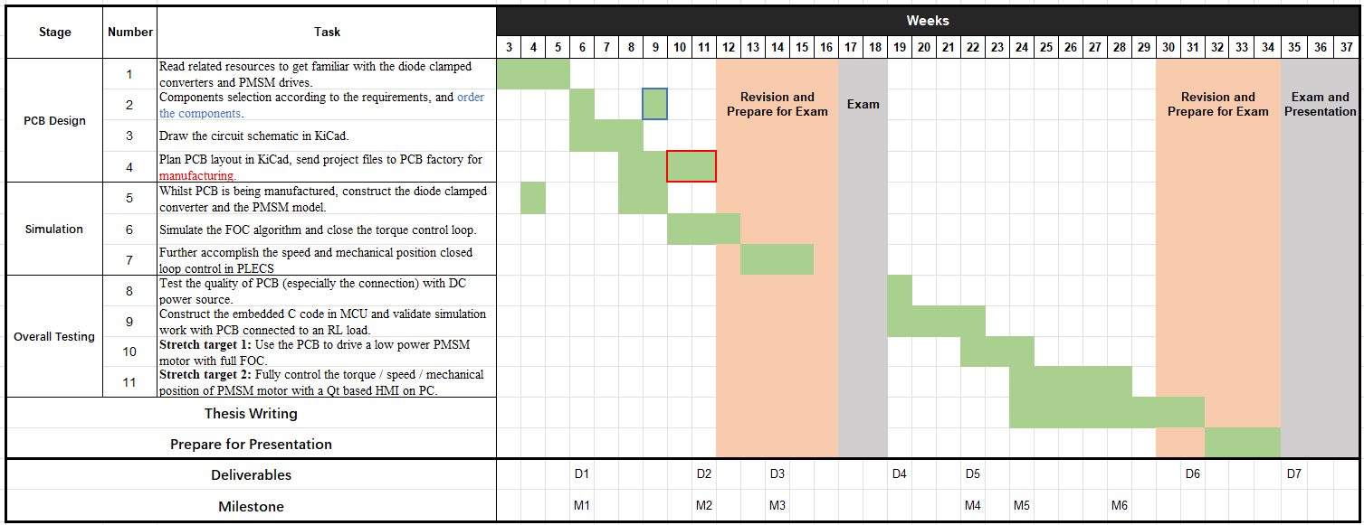

1. **Reference**

[1] B. Wu, “High Power Converters and AC Drives”, Wiley IEEE, 2nd Edition, 2016

[2] G. Abad, “Power Electronics and Electric Drives for Traction Applications”, Wiley, 2016

[3] A. Hughes “Electric Motors and Drives: Fundamentals, types, and applications”, 5th Edition, Elsevier, 2019

[4] S. N. Vukosavic, “Electrical Machines”, Springer, 2012